Darcy Grimaldo Grigsby
History of Art 180C
Spring 2020
TuTh 11-12:30
160 Kroeber Hall

The Spectacle of Modernity: Art and Technologies in late 19th-Century Paris

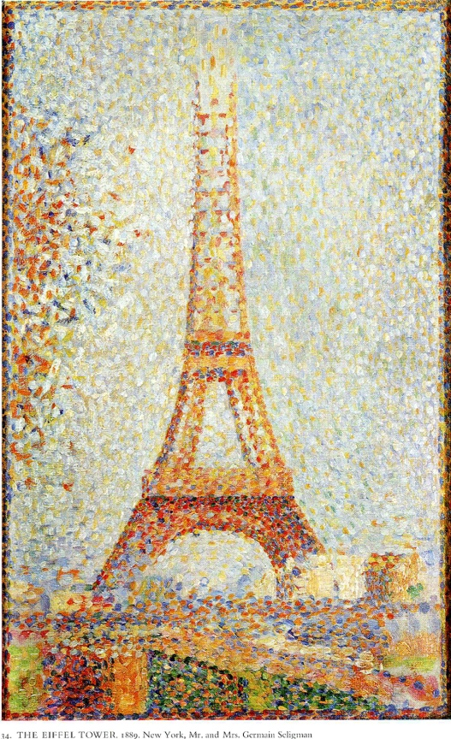

What form can be given to modernity? What were politics of modern self-fashioning and visual culture in Paris, the city Walter Benjamin famously called “the Capital of the Nineteenth Century”? This class will focus on the period from the 1860s to 1900s, considering not only the avant-garde painting movements typically called Impressionism and Post-Impressionism but also the broader visual culture of late 19th-century France. Painting and sculpture need to be examined side by side with the era’s proliferating, game-changing technological innovations that radically altered the city itself and Parisians’ relationship to the newly defined urban spaces. Painters and sculptors struggled to give form to new social spaces and human behaviors. They practiced an art with a long and distinguished tradition while challenged by the advent of photography, the mass press, universal exhibitions and new conceptions of time. The politics of class, gender, and race will be key to our interrogation a bourgeois society in the making. And we will ask how France’s imperial ambitions enabled and impinged upon the Second Empire’s extravagant celebrations of a contested modernity. In addition to a lively secondary scholarship, we will read primary texts by Walter Benjamin, Charles Baudelaire, Emile Zola, Karl Marx, and Villiers-sur-l’Adam, among others.

